MINUTES OF THE MEETING
OF THE BOARD OF TRUSTEES OF

HERITAGE PARK MANAGEMENT CORPORATION

Held on 2 June 2021, Wednesday, 2:00 P.M.
Conducted through Remote Communication due to COVID-19 Pandemic

PRESENT: | ALSO PRESENT:
GREGORIO D. GARCIA III  MONICO V. JACOB  MARIA LYDIA L. ENRIQUEZ  EUSEBIO H. TANCO  AILEEN ANUNCIACION R. ZOSA  ABSENT:  SANTIAGO S. CUA, JR.  VIVENCIO B. DIZON | CARLO RIEZA – Rosehills Memorial Management Philippines, Inc. (“RMMI”)  VICTOR C. TAN – RMMI  FEMA D. SAGUM – RMMI  MA. ANNA ANNETTE A. ESTACION – RMMI  ANITA RODRIGUEZ – Canete, Rodriguez and Associates CPA  MA. ALMA C. SESE – Perez, Sese, Villa & Co.  JERBY B. TORRES – Perez, Sese, Villa & Co.  ROMEO A. DE JESUS, JR. – R.S. Bernaldo & Associates (‘’RSB’’)  JUN PAPA - RSB  ROWENA MARIANNE R. EVIDOR – Bases Conversion and Development Authority (‘’BCDA’’)  ALVIN ANDRE R. CLEMENTE – BCDA  ARSENIO C. CABRERA, JR.  LE IRIS T. LUCIDO
===========================================================

- CALL TO ORDER

The Chairman, Mr. Gregorio D. Garcia III (“Chairman Garcia”), called the meeting to order and presided over the same. The Corporate Secretary, Atty. Arsenio C. Cabrera, Jr., recorded the minutes of the proceedings.

II. CERTIFICATION OF NOTICE AND QUORUM

The Corporate Secretary certified that the notices of the meeting were sent to all members of the Board of Trustees.

The Corporate Secretary stated that the meeting is being conducted through remote communication pursuant to Section 52 of the Revised Corporation Code of the Philippines which provides that trustees who cannot physically attend or vote at board meetings can participate and vote through remote communication such as videoconferencing, teleconferencing, or other alternative modes of communication that allow them reasonable opportunities to participate.

The Corporate Secretary thereafter conducted a roll call of the trustees present. All trustees attended the meeting through remote communication via Zoom. The trustees specified their location and the device being used. The trustees confirmed that they could completely and clearly hear and/or see each other. They likewise confirmed receipt of the agenda and all of the materials for the meeting. They also agreed that a record of the meeting will be taken.

After the roll call and foregoing confirmations, the Corporate Secretary, thereafter, certified as to the existence of quorum for the valid transaction of business.

III. APPROVAL OF PREVIOUS MINUTES

Upon motion duly made and seconded, the Minutes of the Meeting of the Board of Trustees held on 29 April 2021 were unanimously approved.

IV. APPROVAL OF THE AUDITED FINANCIAL STATEMENTS
OF HERITAGE PARK MANAGEMENT CORPORATION AND
THE HERITAGE PARK PROJECT-PERPETUAL CARE FUND
TRUST (HPP-PCF) FOR THE YEAR ENDED 31 DECEMBER 2020

Mr. Jerby B. Torres (‘’Mr. Torres’’) presented for the approval of the Board of Trustees the Audited Financial Statements of Heritage Park Management Corporation (‘’HPMC’’) and the Heritage Park Project Perpetual Care Fund Trust for the year ended 31 December 2020.

The highlights of his presentation were as follows:

- Audited Financial Statements of HPMC

- Total assets for the year ended 31 December 2020 is at PhP11,398,124 vis-à-vis total assets for the year ended 31 December 2019 at PhP2,116,021.

- Other Non-Current Assets for the year ended 31 December 2020 amounted to PhP8,338,310.

- There was a significant increase in the Payables from PhP1,587,254 for the year ended 31 December 2019 to PhP10,869,357 for the year ended 31 December 2020. The increase is attributable to the Non-Current Assets of PhP8,338,310.

- The appropriated operating fund increased from PhP230,715 for the year ended 31 December 2019 to PhP2,003,392 for the year ended 31 December 2020. The increase is attributable to the professional fees of R.S. Bernaldo and Associates relating to the audit of the General Fund.

- The fund balance of revenues and expenses in the Statements of Changes in members’ equity increased from PhP230,800 for the year ended 31 December 2019 to PhP2,003,500 for the year ended 31 December 2020.

- Cash consists of cash in bank amounting to PhP1,010,193 for the year ended 31 December 2020 via-a-vis PhP157,600 for the year ended 31 December 2019.

- The Investment in Trust is set forth below:

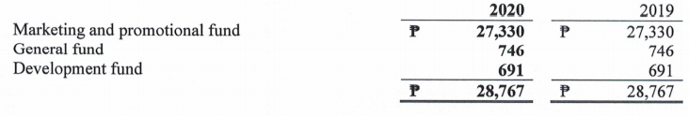

- The Other Current Assets include Input Value Added Tax (‘’VAT’’) of PhP1,928,142 for the year ended 31 December 2019 to PhP2,019,342 for the year ended 31 December 2020.

In reply to the query of Mr. Eusebio H. Tanco (“Mr. Tanco’’), Mr. Torres stated that the Corporation does not claim the Input VAT from Perpetual Care Fund since it has a deficit of PhP324 Million for the year ended 31 December 2020.

- The property and equipment are fully depreciated. The depreciation expense for the year ended 31 December 2020 is PhP143,983.

- The Other Non-Current Asset includes Development Cost amounting to PhP7,306,705 for the year ended 31 December 2020. The development cost pertains to the construction of Heritage Heights. The payables for the year ended 31 December 2020 amounted to Php9,527,803. The payables include the advances from Rosehills Memorial Management Philippines, Inc. (‘’RMMI’’) relating to the development of the Heritage Heights.

- The professional and consulting fees increased from PhP228,000 for the year ended 31 December 2019 to PhP1,990,000 for the year ended 31 December 2020. This is attributable to the professional fees of R.S. Bernaldo & Associates relating to the audit of the General Fund.

- The Corporation as a non-stock, non-profit company is exempted from income tax under Section 30 of the Tax Code. The Corporation, however, has not filed its application for the tax exemption ruling.

- Some of the provisions of the Corporate Recovery and Tax Incentives for Enterprises Act (Republic Act No. 11534) which may have impact on the Corporation’s operations, the Impact of COVID-19 Pandemic to the Corporation, and other Supplementary Information required by the Bureau of Internal Revenue are set forth in Annex ‘’A’’.

- Heritage Heights Development Cost

Mr. Carlo L. Rieza (‘’Mr. Rieza’’), representative of RMMI, presented to the Board of Trustees the Heritage Heights Development Cost as set forth below:
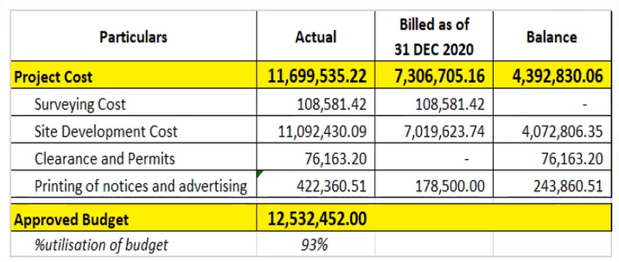

Mr. Rieza stated that the Site Development Cost includes paving of the roads, installation of lamp posts, and access to electricity and water. RMMI paid the Development Cost for the Heritage Heights and subsequently billed the Corporation for the said Development Cost.

In reply to the query of Mr. Monico V. Jacob (‘’Mr. Jacob’’), Mr. Rieza stated that the Corporation will pay RMMI once selling of the estate lots in the Heritage Heights has commence. Mr. Rieza also stated that the payment will be on a per estate lot basis.

In reply to the query of Chairman Garcia, Mr. Rieza stated that the issuance of the permits and licenses is the only hindrance in selling the estate lots at the Heritage Heights.

- Audited Financial Statements of Heritage Park Project Perpetual Care Fund Trust

- Total assets for the year ended 31 December 2020 is at PhP678,948,270 vis-à-vis total assets for the year ended 31 December 2019 at PhP702,610,342. The decrease in the total assets is attributable to the decline in cash and cash equivalents as well as the financial assets at fair value through other comprehensive income.

- The total payables of PhP104,127,114 for the year ended 31 December 2020 include the payables to the General Fund amounting to PhP92,409,443.

- The total revenue for the year ended 31 December 2020 is at PhP50,258,708. The revenues came from (i) interest income on investments, loan and deposits and (ii) rental and miscellaneous income.

- The total expenses for the year ended 31 December 2020 is at PhP50,608,328.

- The total comprehensive loss for the year ended 31 December 2020 is at PhP3,960,205.

- The additional contributions for the year ended 31 December 2020 amounting to PhP1,514,979 include contributions to the PCF from the Pavilion niches sales.

- The net loss for the year ended 31 December 2020 amounted to PhP349,620.

- Total equity declined from PhP554,360,595 for the year ended 31 December 2019 to PhP551,915,369 for the year ended 31 December 2020.

- The cash and cash equivalents declined from PhP179,101,990 for the year ended 31 December 2019 to PhP157,921,852 for the year ended 31 December 2020. The decrease is attributable to the decline in the interest earned from financial assets from PhP5,523,240 in 2019 to PhP2,306,454 in 2020.

- The total receivables increased from PhP32,712,560 for the year ended 31 December 2019 to PhP37,338,504 for the year ended 31 December 2020. The receivable from general fund, which is pending audit, amounting to PhP25,514,224 is the same for 2019 and 2020.

The breakdown of receivables is set forth below:

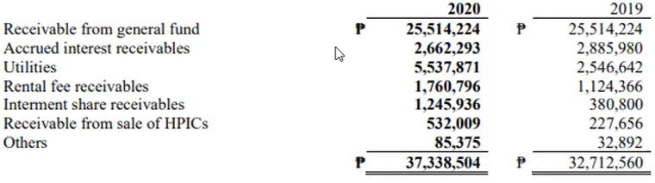

- The inventory-securities are set forth below:
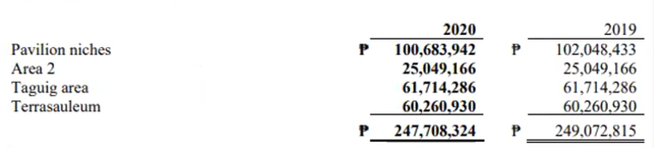

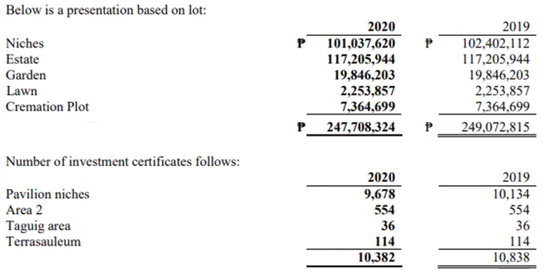

- The pre-payments and other current assets are set forth below:

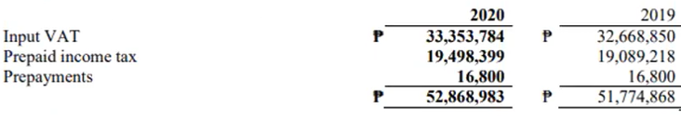

- Financial asset at fair value through other comprehensive income is set forth below:

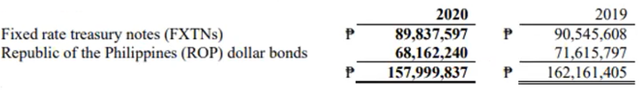

The decline is due to the investment in ROP dollar bonds wherein fair value of $1,419,367 (@48.04) and $1,414,354 (@50.64) for the years ended 31 December 2020 and 31 December 2019, respectively.

The interest income from PhP15,919,878 for the year ended 31 December 2020 to PhP13,232,064 for the year ended 31 December 2019.

- The depreciation expense for the year ended 31 December 2020 amounted to PhP3,292,456.

- Other non-current asset pertains to the Geographic Information System (‘’GIS’’) database of the Heritage Park amounting to PhP2.6 Million. The GIS database is in an on-going development stage.

- Total payables decreased from PhP114,466,321 for the year ended 31 December 2019 to PhP104,127,114 for the year ended 31 December 2020.

The breakdown of the payables is set forth below:

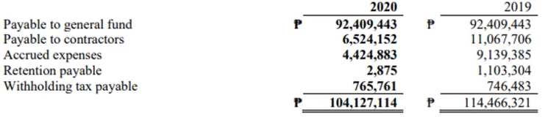

The payable to general fund pertains to funds to be remitted to the General Fund as a result of the Variation Agreement dated 27 June 2014 between the Corporation and RMMI.

- The balance of the unearned revenues from the advance lease payments of Pilipinas Shell Petroleum Corporation (‘’Shell’’) as of 31 December 2020 is PhP12,811,461. The lease contract with Shell will expire in February 2022.

- The funds and contribution are set forth below:

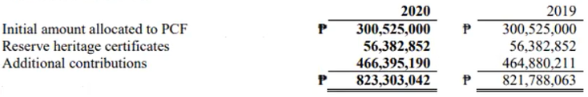

- The revenues are set forth below:
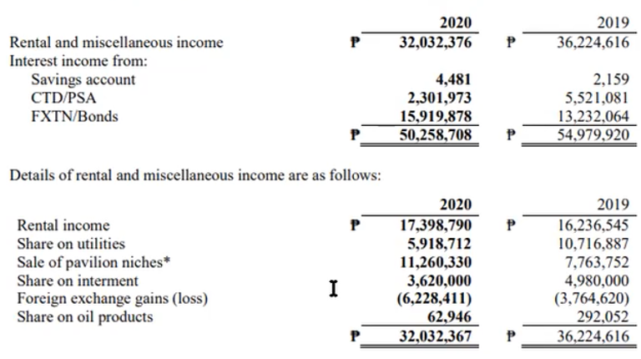

- The details of expenses are set forth below:

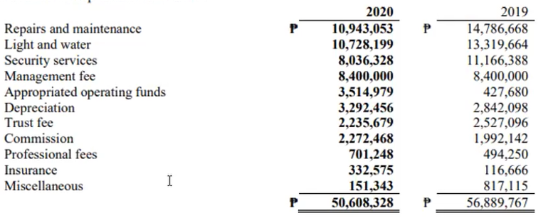

The decline in the operating expenses is due to COVID-19 Pandmic which limits the activities at the Heritage Park.

- The Other Comprehensive Income is set forth below:
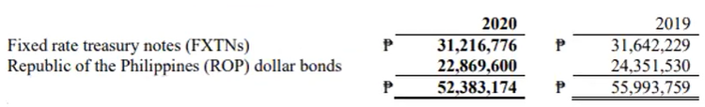

- In reply to the query of Mr. Eusebio H. Tanco (‘’Mr. Tanco), Mr. Torres stated that the Corporate Recovery and Tax Incentives for Enterprises ACT (Republic Act No. 11534) has no effect to the PCF due to its deficit of PhP323 Million.

Atty. Cabrera stated that the Audited Financial Statements of HPMC and the Heritage Park Project Perpetual Care Fund Trust for the year ended 31 December 2020 will be subject for approval by the certificateholders during the 2021 Annual Certificateholders’ Meeting.

Messrs. Jacob and Tanco pointed out the PCF deficit may be filled in by selling the Heritage Heights Project and the development of the Lagoon Island.

After discussion, and upon motion duly made and seconded, the Board of Trustees unanimously approved the following resolutions:

Resolution No. 2021-BD-16-A

“RESOLVED, That the Board of Trustees approve, as it hereby approves, the Audited Financial Statements of the Corporation for the year ended 31 December 2020;

“RESOLVED, FURTHER, That the Board of Trustees authorize, as it hereby authorizes, the following corporate officers of the Corporation to sign and execute the Statement of Management’s Responsibility for Financial Statements, and to submit/file the Audited Financial Statements of the Corporation to the appropriate government agencies in accordance with the requirements of applicable laws and regulations:

Name | Position
Gregorio D. Garcia III | Chairman of the Board of Trustees
Monico V. Jacob | President
Santiago S. Cua, Jr. | Treasurer

“RESOLVED, FINALLY, That the Board of Trustees authorize, as it is hereby authorizes, the Corporation’s external auditor, Perez, Sese, Villa, & Co., to release the Audited Financial Statements of the Corporation for the year ended 31 December 2020.”

Resolution No. 2021-BD-16-B

“RESOLVED, That the Board of Trustees approve, as it hereby approves, the Audited Financial Statements of the Heritage Park Project Perpetual Care Fund Trust for the year ended 31 December 2020;

“RESOLVED, FURTHER, That the Board of Trustees authorize, as it hereby authorizes, the following corporate officers of the Corporation to sign and execute the Statement of Management’s Responsibility for Financial Statements, and to submit/file the Audited Financial Statements of the Heritage Park Project Perpetual Care Fund Trust to the appropriate government agencies in accordance with the requirements of applicable laws and regulations:

Name | Position
Gregorio D. Garcia III | Chairman of the Board of Trustees
Monico V. Jacob | President
Santiago S. Cua, Jr. | Treasurer

“RESOLVED, FINALLY, That the Board of Trustees authorize, as it is hereby authorizes, the Corporation’s external auditor, Perez, Sese, Villa, & Co., to release the Audited Financial Statements of the Heritage Park Project Perpetual Care Fund Trust for the year ended 31 December 2020.”

V. FINANCIAL REPORT OF HPMC
AND HPP-PCF AS OF 31 MAY 2021

Ms. Anita Rodriguez (‘’Ms. Rodriguez’’), representative of Canete, Rodriguez and Associates CPA, presented to the Board of Trustees the Financial Report of HPMC and Heritage Park Project Perpetual Care Fund Trust as of 31 May 2021.

The Statements of Assets, Liabilities and Fund Balance of the Corporation are set forth below:

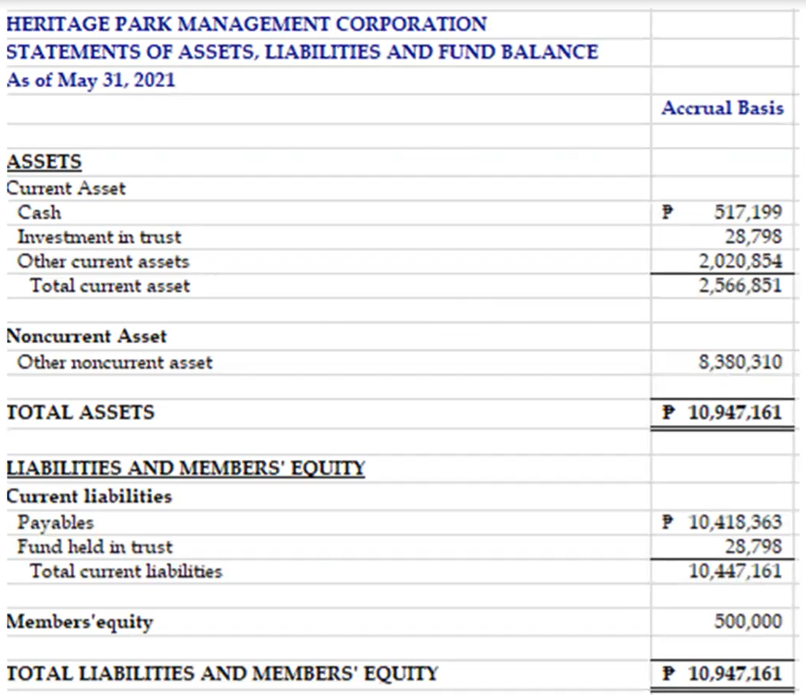

Ms. Rodriguez stated that the deduction in the cash asset pertains to payment to R.S. Bernaldo & Associates and RBC Canete, Rodriguez and Associates CPA.

The Statements of Receipts and Disbursements from January to May 2021 are set forth below:

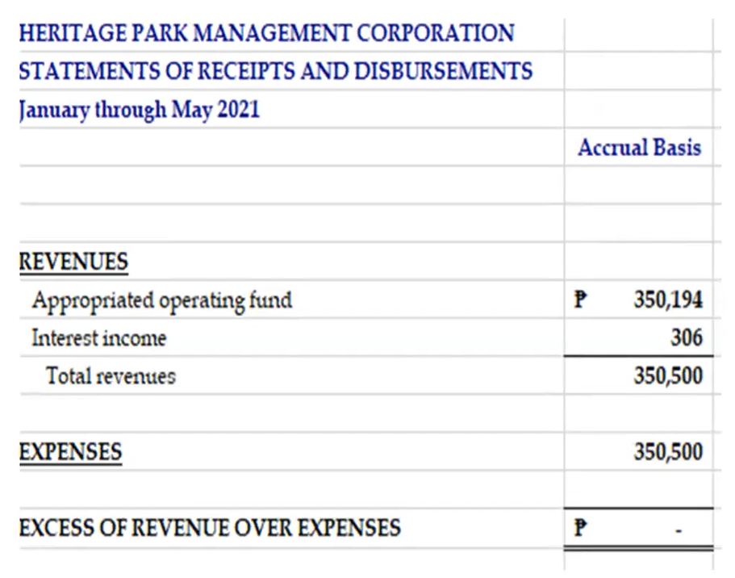

The Profit and Loss of Heritage Park Project Perpetual Care Fund Trust from January to March 2021 is set forth below:

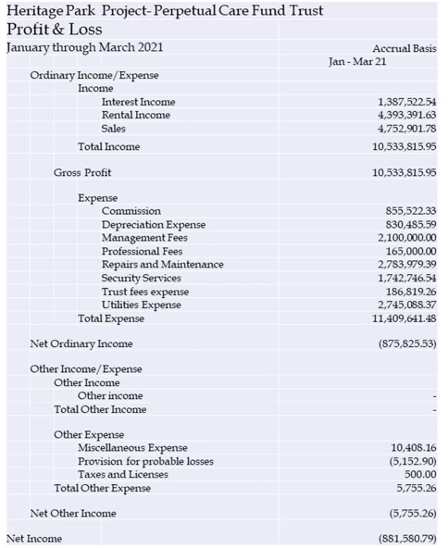

Ms. Rodriguez stated that the Gross Profit and Interest Income may still change upon receipt of financial statements from Philippine National Bank. She also stated that except for Interest Income and Trust Fees expense, the items in the financial report are accrued for three (3) months.

In reply to the query of Mr. Tanco, Ms. Aileen Anunciacion R. Zosa (‘’Ms. Zosa’’) stated that total fund of Heritage Park Project Perpetual Care Fund Trust is about PhP600 Million. In reply to the query of Mr. Tanco. Ms. Rodriguez stated that Pavilion niches is included in the Heritage Park Project Perpetual Care Fund Trust.

In reply to the query of Mr. Tanco, Ms. Rodriguez stated that PNB’s trust fees is about 0.0375% of the total assets.

Mr. Tanco stated that the interest income may be projected and accrue and that there might be net income, rather than a net loss.

In reply to the query of Mr. Tanco, Ms. Rodriguez stated that the Financial Report will be updated based on the data from PNB and thereafter will be circulated to the Board of Trustees.

VI. REPORT ON AUDIT OF THE GENERAL FUND

Messrs. Romeo A. De Jesus, Jr. (‘’Mr. De Jesus’’) and Jun Papa, representatives of R.S. Bernaldo & Associates, presented to the Board of Trustees the Status Report on the Audit of the General Fund as of 2 June 2021. A copy of the Status Report is set forth in Annex ‘’B’’. Mr. De Jesus pointed out that the Status Report is based on the available documents which were furnished to R.S. Bernaldo & Associates.

In reply to the query of Mr. Tanco, Ms. Zosa stated that this is the first time that the General Fund is being subject to audit.

In reply to the query of Mr. Jacob, Ms. Zosa stated that the General Fund is one of the Heritage Park accounts which include four (4) other funds, namely: Perpetual Care Fund, Marketing and Promotional Fund, Relocation Fund, and Construction/Development Fund. Ms. Zosa stated that the reason for the audit is the receivables of the General Fund from the Perpetual Care Fund on the account for spending on the development of Pavilion. She pointed out that the General Fund does not get any share from the sales of Pavilion niche while Perpetual Care Fund gets share from the sales of Pavilion niche. Ms. Zosa further stated that it appears the based on the Minutes of the meetings, the Investment Committee made the decision relating to the transfer of funds from the General Fund, not the Board of Trustees. Ms. Zosa likewise stated that one of the theories for the transfer of funds is it appears that the Development Fund has been exhausted but the development of the Heritage Park has not yet been completed.

In reply to the query of Chairman Garcia, Ms. Zosa stated that previously the development at the Heritage Park is being handled by the Public Estates Authority.

In reply to the query of Chairman Garcia, Ms. Zosa stated that there is a need to complete the examination of the documents (i.e. disbursement instruction, check vouchers, Minutes of the meetings) from PNB which consist of about 50 boxes.

Ms. Zosa pointed out that under the Pool Formation Trust Agreement executed among Bases Conversion Development Authority (‘’BCDA’’), Public Estates Authority, and PNB, once the Heritage Park Project has been completed, the General Fund will inure to BCDA. The Commission on Audit may inquire about the General Fund.

Mr. De Jesus stated that R.S. Bernaldo & Associates will complete the examination of the documents relating to the General Fund and thereafter report its audit findings to the Board of Trustees.

After discussion, and upon motion duly made and seconded, the Board of Trustees noted the Status Report on the Audit of the General Fund.

VII. UPDATE ON ANNUAL CERTIFICATEHOLDERS’ MEETING

Ms. Ma. Anna Annette A. Estacion (‘’Ms. Estacion’’), representative of RMMI, presented to the Board of Trustees the proxy update as set forth in Annex ‘’C’’.

Ms. Estacion also presented the Checklist of Tasks as set forth below:

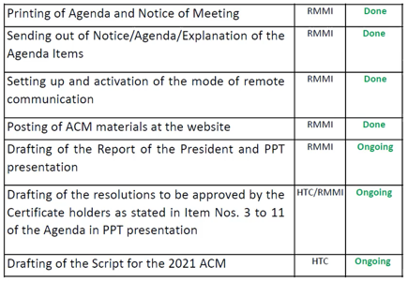

Ms. Estacion likewise presented the important dates to remember relating to the 2021 Annual Certificateholders’ Meeting as set forth below:

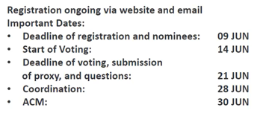

Ms. Estacion further stated that documents relating to the 2021 Annual Certificateholders’ Meeting are already posted in the Corporation’s website. She further stated that the Online Voting Form is currently being finalized.

After discussion, and upon motion duly made and seconded, the Board of Trustees noted the update on the 2021 Annual Certificateholders’ Meeting.

VIII. DESIGNATION OF PROXY FOR THE ANNUAL CERTIFICATEHOLDERS’ MEETING OF THE CORPORATION .

Atty. Cabrera informed the Board of Trustees that the Corporation will designate Chairman Garcia or Mr. Jacob as its Proxy for the Annual Certificateholders’ Meeting of the Corporation.

After discussion, and upon motion duly made and seconded, the Board of Trustees unanimously approved the following resolutions:

Resolution No. 2021-BD-17

“RESOLVED, AS IT IS HEREBY RESOLVED, That the Corporation appoint, as it hereby appoints, the Corporation's Chairman of the Board of Trustees, Mr. Gregorio D. Garcia III, or the Corporation’s President, Mr. Monico V. Jacob, as its proxy to attend and vote at any and all Certificateholders’ meetings of Heritage Park Management Corporation (‘’HPMC’’), with full power to substitute himself or to designate another person as proxy;

“RESOLVED, FURTHER, That the Corporation authorize, as it hereby authorizes, the Corporate Secretary to sign, execute, and deliver, on behalf of the Corporation, the proxy forms;

“RESOLVED, FINALLY, That this designation of proxy shall remain valid and effective within the period provided in the proxy, unless sooner revoked by a valid resolution of the Board of Trustees.’’

IX. UPDATE ON HERITAGE PARK INVESTMENT CERTIFICATES HELD BY IPM REALTY AND DEVELOPMENT CORPORATION AND THE CORPORATION .

Mr. Rieza presented to the Board of Trustees the update on Heritage Park Investment Certificates (‘’HPICs’’) held by IPM Realty and Development Corporation (‘’IPM’’) and the Corporation.

The highlights of his presentation were as follows:

- The City of Taguig is entitled to 303 HPICs in the area designated as People’s Park in the Heritage Park.

- Prior to 23 April 2002 and upon the instruction of Taguig to PNB, 11 HPICs were issued to R.E. Construction (developer of Taguig City’s People’s Park).

- There are 269 HPICs issued to Municipality of Taguig, 35 of which is to be withheld representing Taguig’s 12% contribution to the Perpetual Care Fund.

- There were 23 additional certificates issued to R.E. Construction based on the contract between R.E. Construction and City of Taguig.

- The issuance of the HPICs is covered by Letter dated 23 May 2002 issued by the former Corporation’s Chairman Florencio F. Padernal to PNB Trust Banking Group and pursuant to the Corporation’s Board Resolution No. 26-3 Series of 2020. This Letter is in accordance with the Letter dated 23 April 2002 issued by former Taguig Mayor, Sigfrido Tinga, to the Corporation.

- The breakdown of 303 HPICs lots is set forth below:

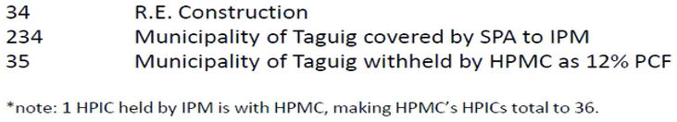

Atty. Cabrera pointed out that the 35 HPICs are still registered in the name of the Municipality of Taguig and are booked as part of the PCF.

- The 234 HPICs registered under Municipality of Taguig is covered by a Special Power of Attorney dated 23 February 2004 wherein IPM was appointed as Attorney-in-Fact of the Municipality of Taguig to perform the following:

- Act as exclusive Marketing Services Agent of Taguig to undertake the marketing, sale and disposition of the 234 HPICs owned by Taguig;
- Execute and deliver to buyers/assignees of the HPICs the requisite deed of sale or assignment/contract to sell/purchase agreement evidencing sale, transfer, assignment or disposition of the HPICs; and
- Demand and secure from the Escrow Agent the release, transfer and delivery of the HPICs to buyers/assignees that have fully paid the purchase price of their HPICs.

The SPA is also coupled with interest and subject to and co-terminus with the Marketing Agreement executed by Taguig and IPM.

Mr. Rieza will obtain copy of the foregoing Marketing Agreement.

- Based on internal meeting with IPM, its lots in Brgy. Hagonoy, Taguig City were swapped and developed by Taguig into public cemetery which is exclusive for the residents of Taguig.

In reply to the query of Chairman Garcia, Mr. Rieza stated that he will check the latest transfer of HPICs by IPM based on the SPA.

In reply to the query of Mr. Jacob, Mr. Rieza stated that Aeternum’s original project of five (5) buildings of columbarium were reduced to one (1) building of columbarium. He also stated that Aeternum reverted to selling the proposed columbarium area for estate lots.

Messrs. Jacob and Tanco pointed out that the development in the Heritage Park should be pursuant to the Master Development Plan.

In reply to the query of Chairman Garcia, Mr. Rieza will ask the contact person of IPM at the City of Taguig.

Mr. Jacob suggested that Management set up an internal meeting to further discuss this matter.

After discussion, and upon motion duly made and seconded, the Board of Trustees noted the update on HPICs held by IPM and the Corporation.

X. UPDATE ON MIGRATION TO LAND BANK OF THE PHILIPPINES

Ms. Zosa informed the Board of Trustees that the Perpetual Care Fund Trust Agreement between the Corporation and Land Bank of the Philippines has already been executed.

Ms. Maria Lydia L. Enriquez (‘’Ms. Enriquez’’) stated that accounts with Land Bank of the Philippines have not yet been opened.

Ms. Zosa requested Ms. Enriquez to check the trust fees of Land Bank of the Philippines.

Mr. Jacob requested Ms. Enriquez to contact and set-up a meeting with the proposed stock transfer agent.

After discussion, and upon motion duly made and seconded, the Board of Trustees noted the update on migration to Land Bank of the Philippines.

XI. REQUEST FOR UTILITIES AT THE CORONA MAUSOLEUM

Mr. Rieza stated that not all estate lots in the Heritage Park have access to water and electricity. The Corporation received a request to provide access to water and electricity to Corona mausoleum.

Mr. Rieza further stated that the cost of materials to provide access to water and electricity to the nine (9) estate lots in the area of Corona mausoleum (including wires and pipes from the nearest access point) is about PhP80,000.00. Mr. Rieza also stated that the labor will be done by the grounds and irrigation personnel at the Heritage Park.

In reply to the query of Mr. Jacob, Ms. Enriquez stated that there will be separate water meter and electricity meter, respectively. The mausoleum will be billed separately for corresponding water and electricity consumption.

In reply to the query of Mr. Jacob, Mr. Rieza stated that out the nine (9) estate lots, three (3) estate lots have already been occupied while six (6) estate lots have already been sold.

In reply to the query of Ms. Zosa, Mr. Rieza stated that the PhP80,000 will cover access to water and electricity to nine (9) estate lots.

Mr. Tanco recommended to study the impact on electrification on the other areas of the Heritage Park. Ms. Zosa pointed out that the electrical system should have capacity to electrify the Heritage Park.

In reply to the query of Mr. Jacob, Mr. Rieza stated that the previous study provides that the cost of electrification at the Heritage Park is about PhP130 Million. Mr. Jacob stated that funds should be raised for the electrification at the Heritage Park. Chairman Garcia stated that electrification at the Heritage Park should be part of the Corporation’s future plans.

After discussion, and upon motion duly made and seconded, the Board of Trustees unanimously approved the following resolutions:

Resolution No. 2021-BD-18

“RESOLVED, That the Board of Trustees hereby approves to provide access to electricity and water to the nine (9) estate lots area in the Heritage Park which include the Corona mausoleum;

“RESOLVED, FURTHER, That the Board of Trustees hereby approves the cost of materials to provide access to electricity and water to the nine (9) estate lots to be billed as part of park repairs and maintenance in an amount not exceeding Eighty Thousand Pesos (PhP80,000.00);

“RESOLVED, FINALLY, That the Board of Trustees hereby approves to provide access to water and electricity for other mausoleum lot owners in the Heritage Park.’’

XII. SHELL CONCERNS

- Third Party Claim

Mr. Rieza informed the Board of Trustees that the Corporation received a Letter from Pilipinas Shell Petroleum Corporation (‘’Shell’’), a lessee in the Heritage Park.

The Letter provides that there appears to be a third-party claimant on the property wherein Shell gas station is located. A certain Avenida S. Hainar is claiming ownership to 1,837.5 hectares covered by Transfer Certificate of Title No. 40738 issued to a certain Santiago Orda and transferred to Avenida S. Hainar.

Mr. Rieza stated that Shell is requesting for a formal reply from HPMC in this matter.

Ms. Zosa that this matter should be referred to BCDA in order to have a wholistic approach.

After discussion, and upon motion duly made and seconded, the Board of Trustees noted the report on the Third Party Claim.

- Unsettled Real Property Tax

The Letter from Shell also provides that due to unsettled real property tax (‘’RPT’’), Jollibee Foods Corporation, one of the tenants of Shell, was not able to renew its business permit. It appears that the unsettled RPT is about PhP157.5 Million.

Management will have internal discussion to address this matter.

XIII. ADJOURNMENT

There being no further business to transact, and upon motion duly made and seconded, the meeting was adjourned.

ARSENIO C. CABRERA, JR.
Corporate Secretary

ATTEST:

GREGORIO D. GARCIA III | MONICO V. JACOB
Chairman/Trustee | Trustee
AILEEN ANUNCIACION R. ZOSA Trustee | MARIA LYDIA L. ENRIQUEZ  Trustee
EUSEBIO H. TANCO
Trustee

ANNEX ‘’A’’

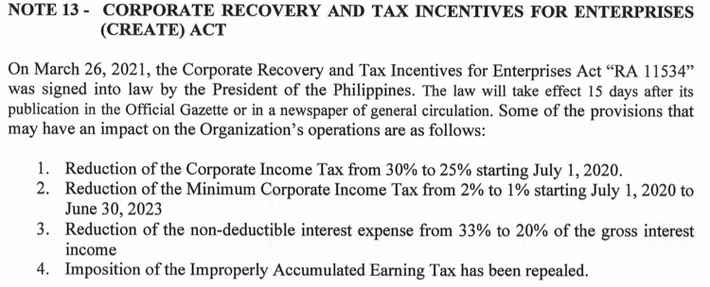
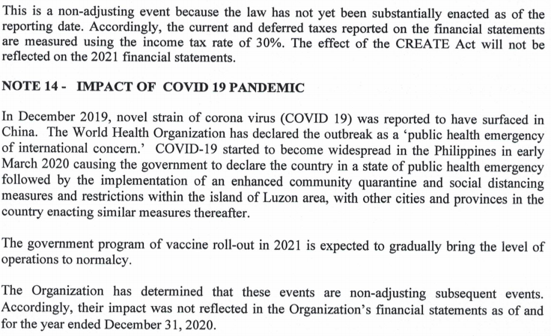

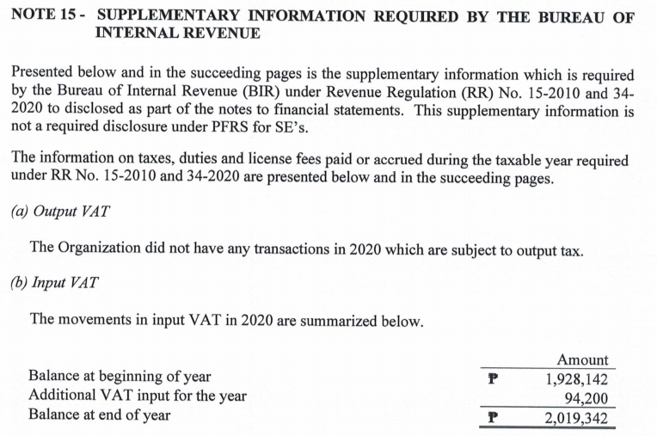
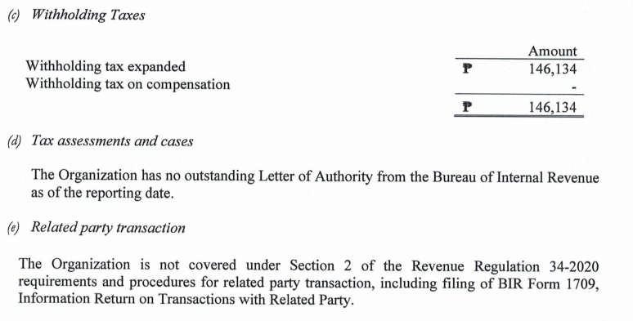

ANNEX ‘’B’’

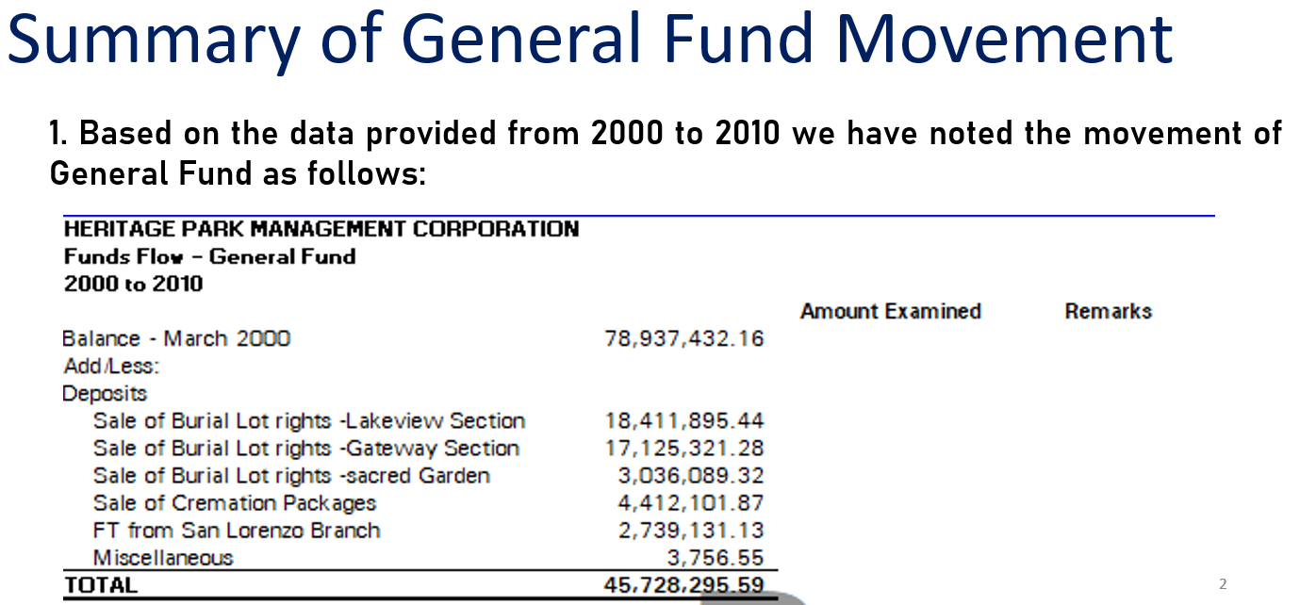

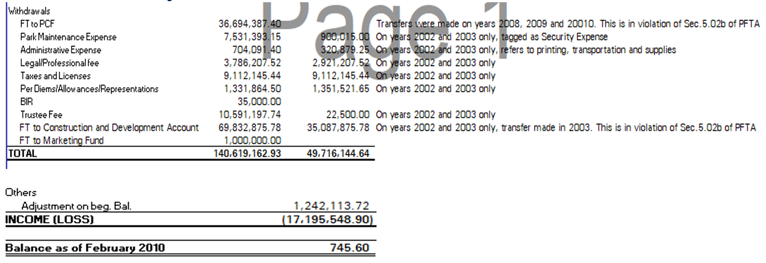

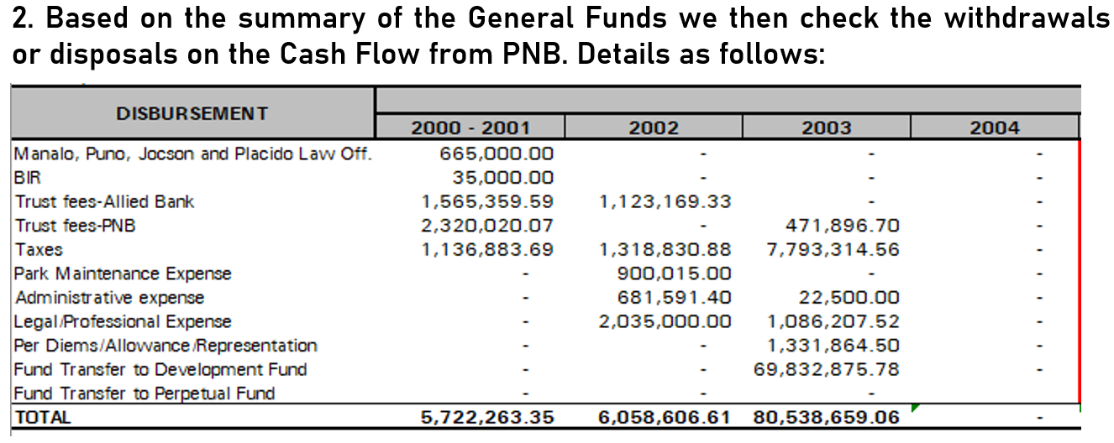

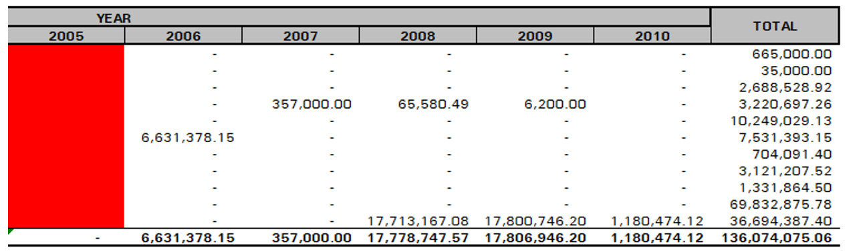

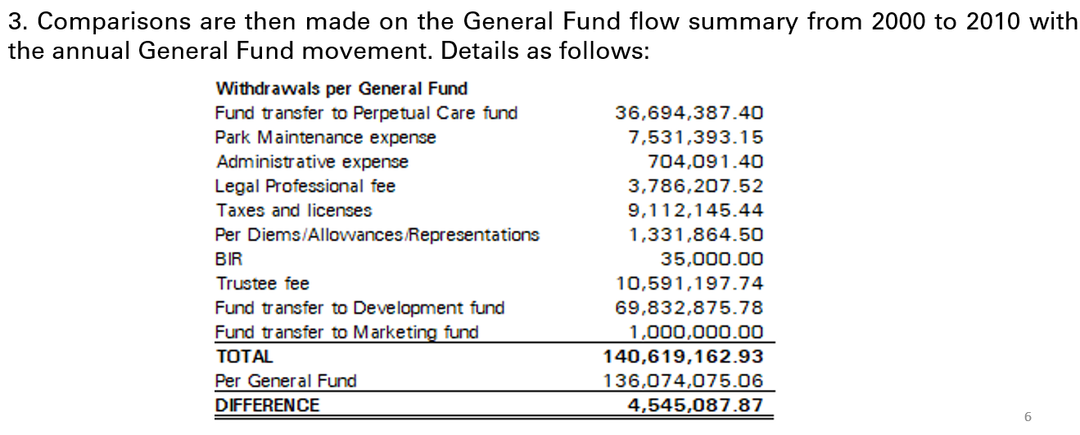
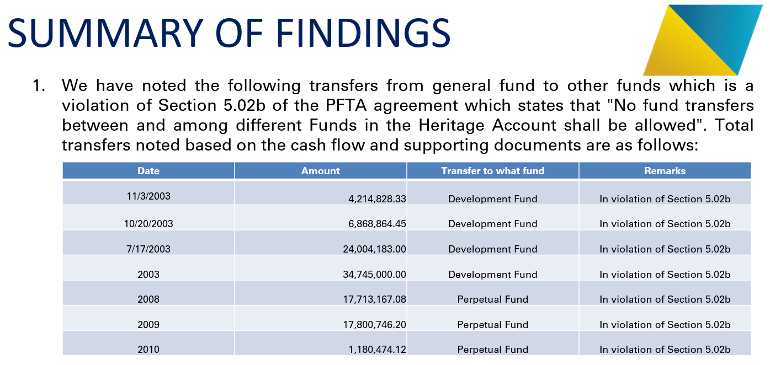

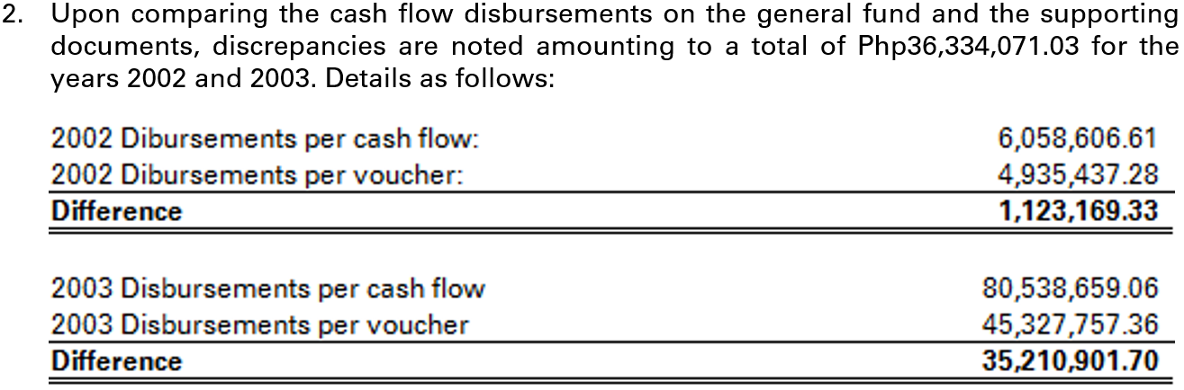

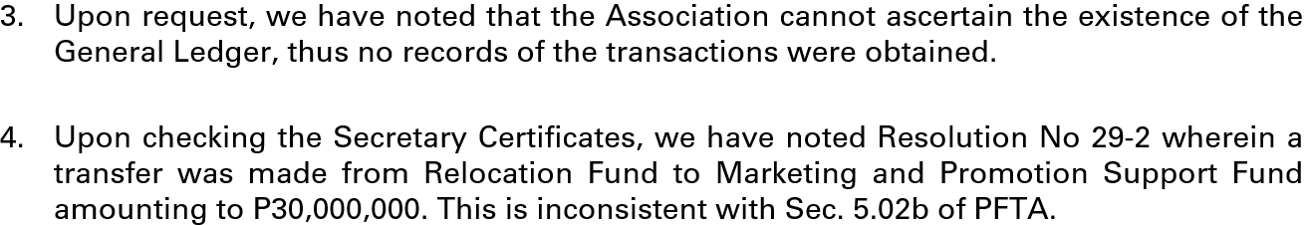

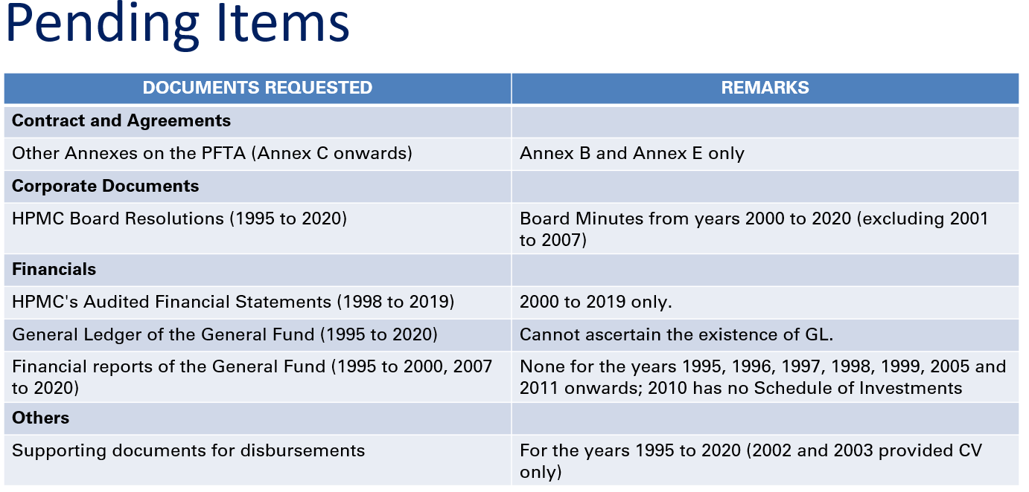
ANNEX ‘’C’’

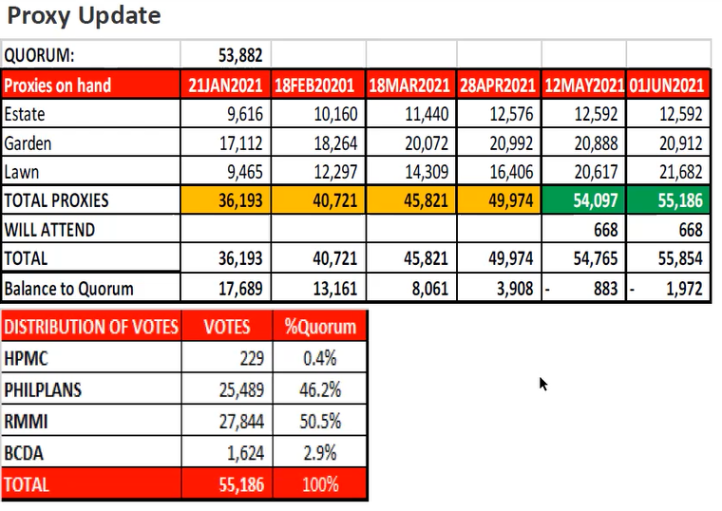

Republic Act No. 11232. An Act Providing for the Revised Corporation Code of the Philippines.

